A simple demonstration for Workplace Inspection Portal

## RELATED EXPERIENCE

## Web Developer

### UQ Occupational Health & Safety Division / Jul 2017 – Nov 2017

Our Team developed a completed web portal for UQ Occupational Health & Safety Division to schedule and perform safety inspections.

As a Web Developer, my responsibilities include:

|  |
| --- |
| Responsibilities:   * Make sure the Scrum Framwork work well * Implementing core functional component by using HTML, CSS, jQuery, PHP and SQL * UI design * User test * Make report every sprint * Finish tasks reqiured by client before sprint review * Manage and implement database * Propose solutions to deal with inside and outside problems |
|
|

I worked with the team to accomplish project goals. In the end, our product meets both deadline and clients' requirements.  **Bootstrap and PHP** were used to construct the web application while MySql as database system. Please visit our product marketing website at the following address.  <https://deco3801-of6.uqcloud.net/marketing/>

As we have signed the Intellectual property agreement with client, we don’t actually own the product now and the access to it is limited as well. However, in this documentation, I will explain some functions of the Workplace Inspection Portal base on local code and give a brief view of the user interface.

1. Following two images are admin page that visualizing visitors’ data, showing some aspects of potential users.

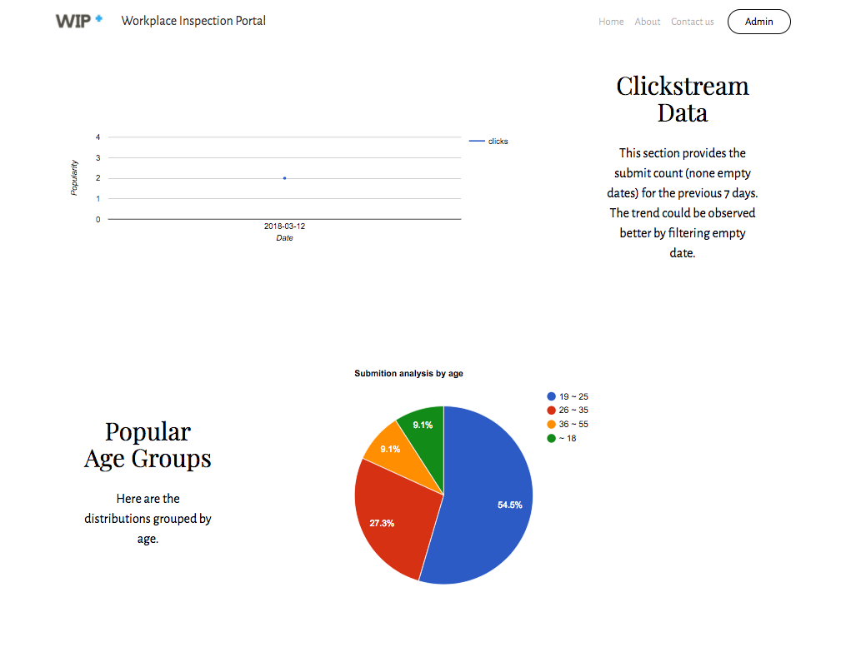

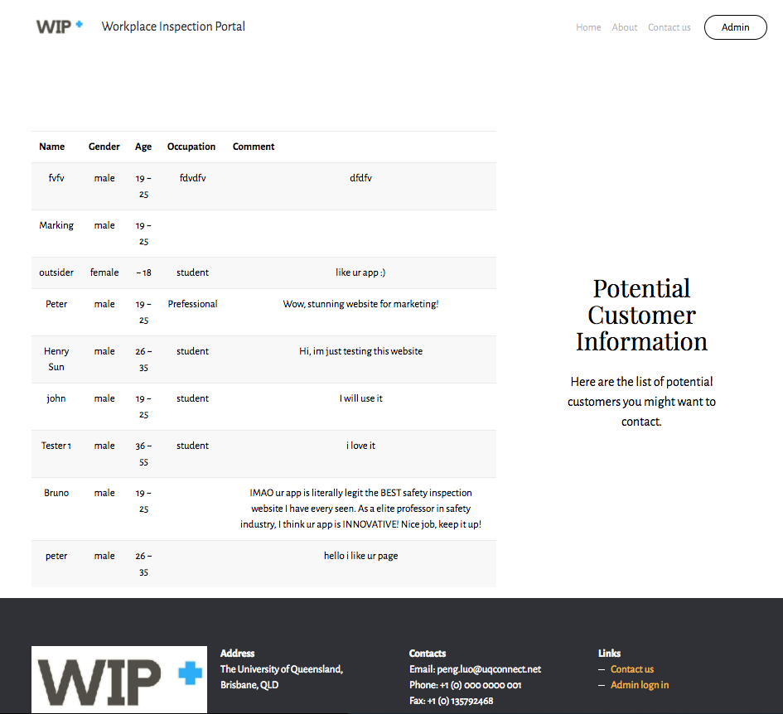

1. Dashboard page for the users to understand current inspection progress.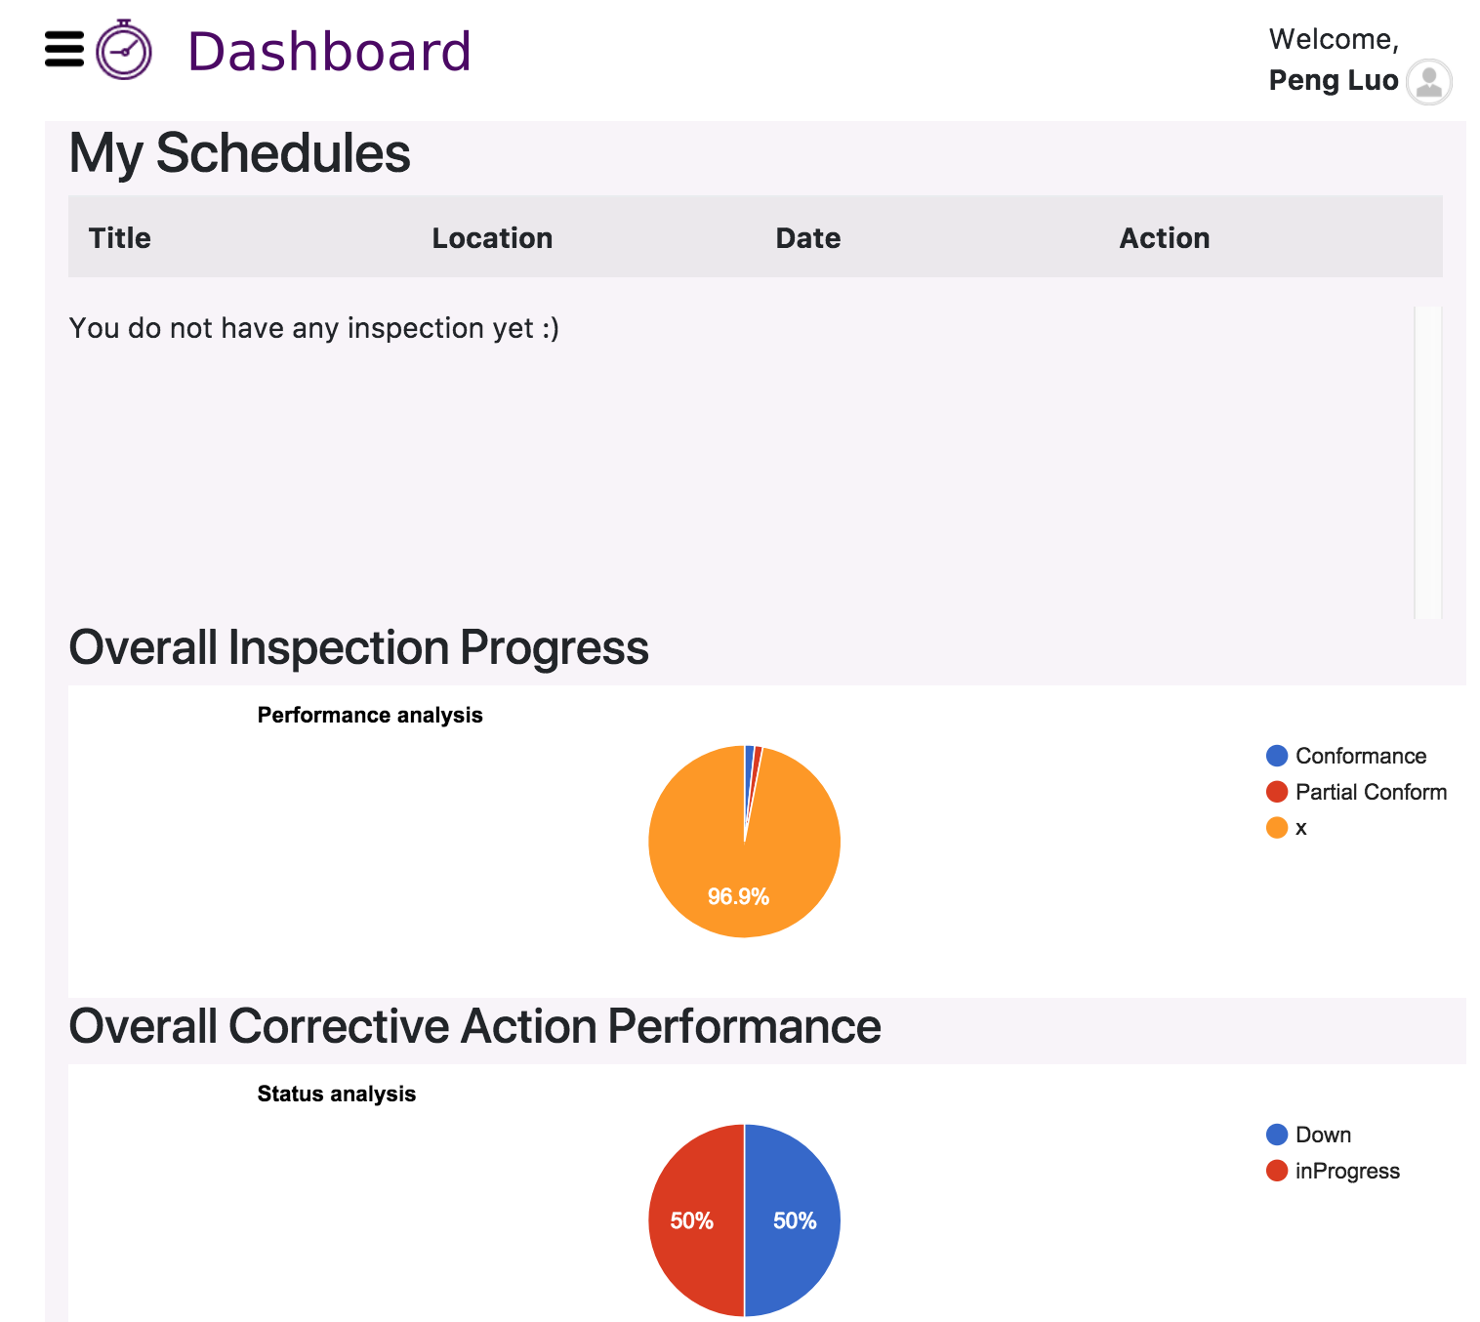
2. This is a page for safety manager to schedule the inspection to coordinators according to their availability.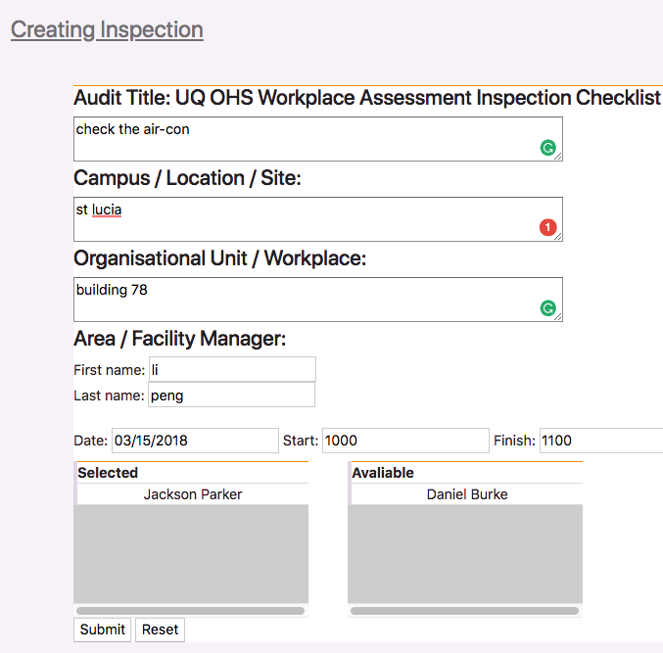

4. Setting page is designed for managers and coordinators to change their availability. Report page provides inspection report to export.

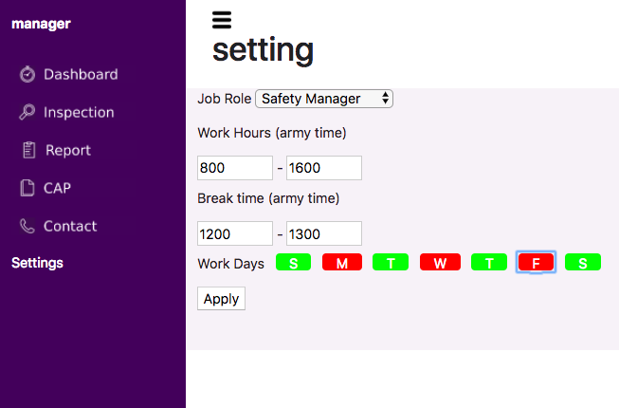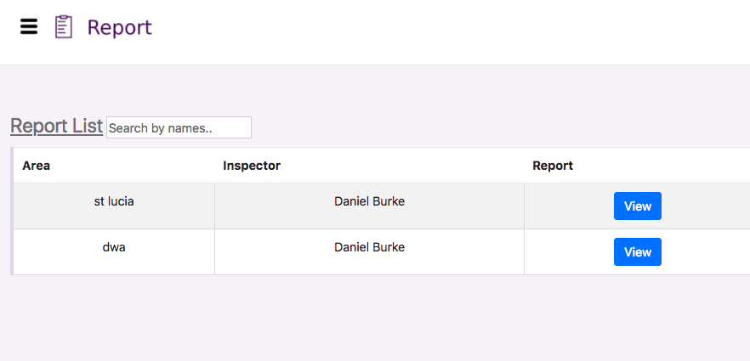

There are many other functions have not been demonstrated in this document, such as recording inspection result, Contact list, cap checklist…